Exercise 5
  - Machine Learning I

4A-1.

We know:
$$p\left(θ\right)=\frac{1}{Δprior}$$
$$p\left(θ_{MAP}|D\right)≈\frac{1}{Δposterior}$$
Using Bayes’ theorem and rearranging terms we get:
$$\begin{matrix} & & p\left(θ|D\right) & =\frac{p\left(D|θ\right)p\left(θ\right)}{p\left(D\right)} \\ \left(*\right) & ≈ & p\left(D\right) & =p\left(D|θ_{MAP}\right)\frac{Δposterior}{Δprior}\end{matrix}$$
The approximately “$≈$” is valid because most density is concentrated around $θ_{Map}$.
As we saw in the lecture slides, the evidence approximation is useful to make inferences about model complexity and fit.
For a more detailed explanation with pictures etc., please refer to page 163, Bishop PRML.
Let us see what happens in $\left(*\right)$ if we vary the input $D$:
As the likelihood $p\left(D|θ\right)$ is strongly related to the fit, $p\left(D\right)$ acquires information about the model fit. As fit is related to model complexity, a better fit often entails a more complex model as well. Additionally, because of $\frac{Δposterior}{Δprior}$ our $p\left(D\right)$ also receives information about model complexity and plausibility.
If $Δposterior$ is too high compared to our belief $Δprior$, then $p\left(D\right)$ goes down. So we combat overfitting by comparing parameter certainty after collecting data (posterior) with how plausible we think these parameters are (prior). If our fit is good ($p\left(D|θ_{MAP}\right)$ high), yet we have a general enough model ($p\left(θ_{MAP}|D\right)$ low), we receive a good value for $p\left(D\right)$.
The optimal value for $p\left(D\right)$ is thereby a balance of model complexity, belief ($\frac{Δposterior}{Δprior}$) and fit ($p\left(D|θ_{MAP}\right)$).

4A-2.

  - This is the general version. The process for only one additional datapoint is exactly the same, you just have to replace the general formula with the one in the task.

Prerequisites
Let $A$ be invertible, $B,C$ arbitrary and $I$ be the identity matrix.
We then have:

$$\left(*\right) {\left(A+BCD\right)}^{-1}=A^{-1}-{\left(I+A^{-1}BCD\right)}^{-1}A^{-1}BCDA^{-1}$$
The proof of above can be seen here:
http://www0.cs.ucl.ac.uk/staff/gridgway/mil/mil.pdf
Also, as seen in the last lecture slides, the posterior of Bayesian linear regression with normal prior is:
$$p\left(w|t,Σ_{N},τ_{e}\right)=N\left(w;μ_{N},Σ_{N}\right)$$
$$μ_{N}=τ_{e}Σ_{N}Φ^{T}t$$
$$Σ_{N}={\left(Σ_{0}^{-1}+τ_{e}Φ^{T}Φ\right)}^{-1}$$
Let us have $K$ old and $M$ “new” datapoints.
Because the predictive distribution is dependent on the posterior, it makes sense to calculate the new posterior first.
As seen in the task, we have:
$$p\left(w|t_{M},t_{K}\right)∝p\left(w|t_{K}\right)p\left(t_{M}|w\right)$$
This leads to:
$$\begin{matrix}p\left(w|t_{K}\right)p\left(t_{M}|w\right) & ∝e^{-\frac{1}{2}\left[{\left(w-μ_{K}\right)}^{T}Σ_{K}^{-1}\left(w-μ_{K}\right)+{\left(t_{m}-Φ_{M}w\right)}^{T}τ_{e}I\left(t_{m}-Φ_{M}w\right)\right]}\end{matrix}$$
Note: We have $τ_{e}I$ because the predictions are independent from each other. Focusing on the exponent:
$$\begin{matrix}{\left(w-μ_{K}\right)}^{T}Σ_{K}^{-1}\left(w-μ_{K}\right)+{\left(t_{M}-Φ_{M}w\right)}^{T}τ_{e}I\left(t_{M}-Φ_{M}w\right) & =w^{T}\underset{Σ_{K+M}^{-1}}{\underbrace{\left(Σ_{K}^{-1}+τ_{e}Φ_{M}^{T}Φ_{M}\right)}}w-2w^{T}\left[Σ_{K}^{-1}μ_{K}+τ_{e}Φ_{M}^{T}t_{M}\right] \\ & +μ_{K}Σ_{K}^{-1}μ_{M}+τ_{e}t_{M}^{T}t_{M} \\ & =w^{T}Σ_{K+M}^{-1}w \\ & -2w^{T}\underset{=1}{\underbrace{Σ_{K+M}^{-1}Σ_{K+M}}}\left[Σ_{K}^{-1}μ_{K}+τ_{e}Φ_{M}^{T}t_{M}\right] \\ & +c\end{matrix}$$
This allows us to complete the square above and we get the updated posterior:
$$p\left(w|t_{M},t_{K}\right)=N\left(w;μ_{M+K},Σ_{K+M}\right)$$
with
$$Σ_{K+M}={\left(Σ_{K}^{-1}+τ_{e}Φ_{M}^{T}Φ_{M}\right)}^{-1}$$
$$μ_{M+K}=Σ_{K+M}\left[Σ_{K}^{-1}μ_{K}+τ_{e}Φ_{M}^{T}t_{M}\right]$$
Note: When $μ_{K}=0$ we get the same result as in the slides for the prior $p\left(w|Σ_{0}\right)$.
Now we use $\left(*\right)$ for the covariance:
$${\left(Σ_{K}^{-1}+τ_{e}Φ_{M}^{T}Φ_{M}\right)}^{-1}=Σ_{K}-τ_{e}{\left(I+τ_{e}Σ_{K}Φ_{M}^{T}Φ_{M}\right)}^{-1}Σ_{K}Φ_{M}^{T}Φ_{M}Σ_{K} \\ As seen in the slides (or the task), we try to show:$$
$$σ_{K+M}\left(x^{*}\right)≤σ_{K}\left(x^{*}\right)$$
where
$$σ_{n}=\frac{1}{r_{e}}+ϕ{\left(x^{*}\right)}^{T}Σ_{N}ϕ\left(x^{*}\right)$$
Now we just plug our new covariance matrices into $σ_{n}$:
$$\begin{matrix}σ_{K+M}\left(x^{*}\right) & =\frac{1}{r_{e}}+ϕ{\left(x^{*}\right)}^{T}{\left(Σ_{K}^{-1}+τ_{e}Φ_{M}^{T}Φ_{M}\right)}^{-1}ϕ\left(x^{*}\right) \\ & =\frac{1}{r_{e}}+ϕ{\left(x^{*}\right)}^{T}\left[Σ_{K}-τ_{e}{\left(I+τ_{e}Σ_{K}Φ_{M}^{T}Φ_{M}\right)}^{-1}Σ_{K}Φ_{M}^{T}Φ_{M}Σ_{K}\right]ϕ\left(x^{*}\right) \\ & =\underset{σ_{K}\left(x^{*}\right)}{\underbrace{\frac{1}{r_{e}}+ϕ{\left(x^{*}\right)}^{T}Σ_{K}ϕ\left(x^{*}\right)}}-ϕ{\left(x^{*}\right)}^{T}\left[τ_{e}{\left(I+τ_{e}Σ_{K}Φ_{M}^{T}Φ_{M}\right)}^{-1}Σ_{K}Φ_{M}^{T}Φ_{M}Σ_{K}\right]ϕ\left(x^{*}\right) \\ & ≤σ_{K}\left(x^{*}\right).\end{matrix}$$
The last equality holds because
$$τ_{e}{\left(I+τ_{e}Σ_{K}Φ_{M}^{T}Φ_{M}\right)}^{-1}Σ_{K}Φ_{M}^{T}Φ_{M}Σ_{K}$$
is at least positive semidefinite (for why, look up the properties of positive semidefinite matrices, especially in regard to $Σ_{K}$ and $Φ_{M}^{T}Φ_{M}$.

4A-3.

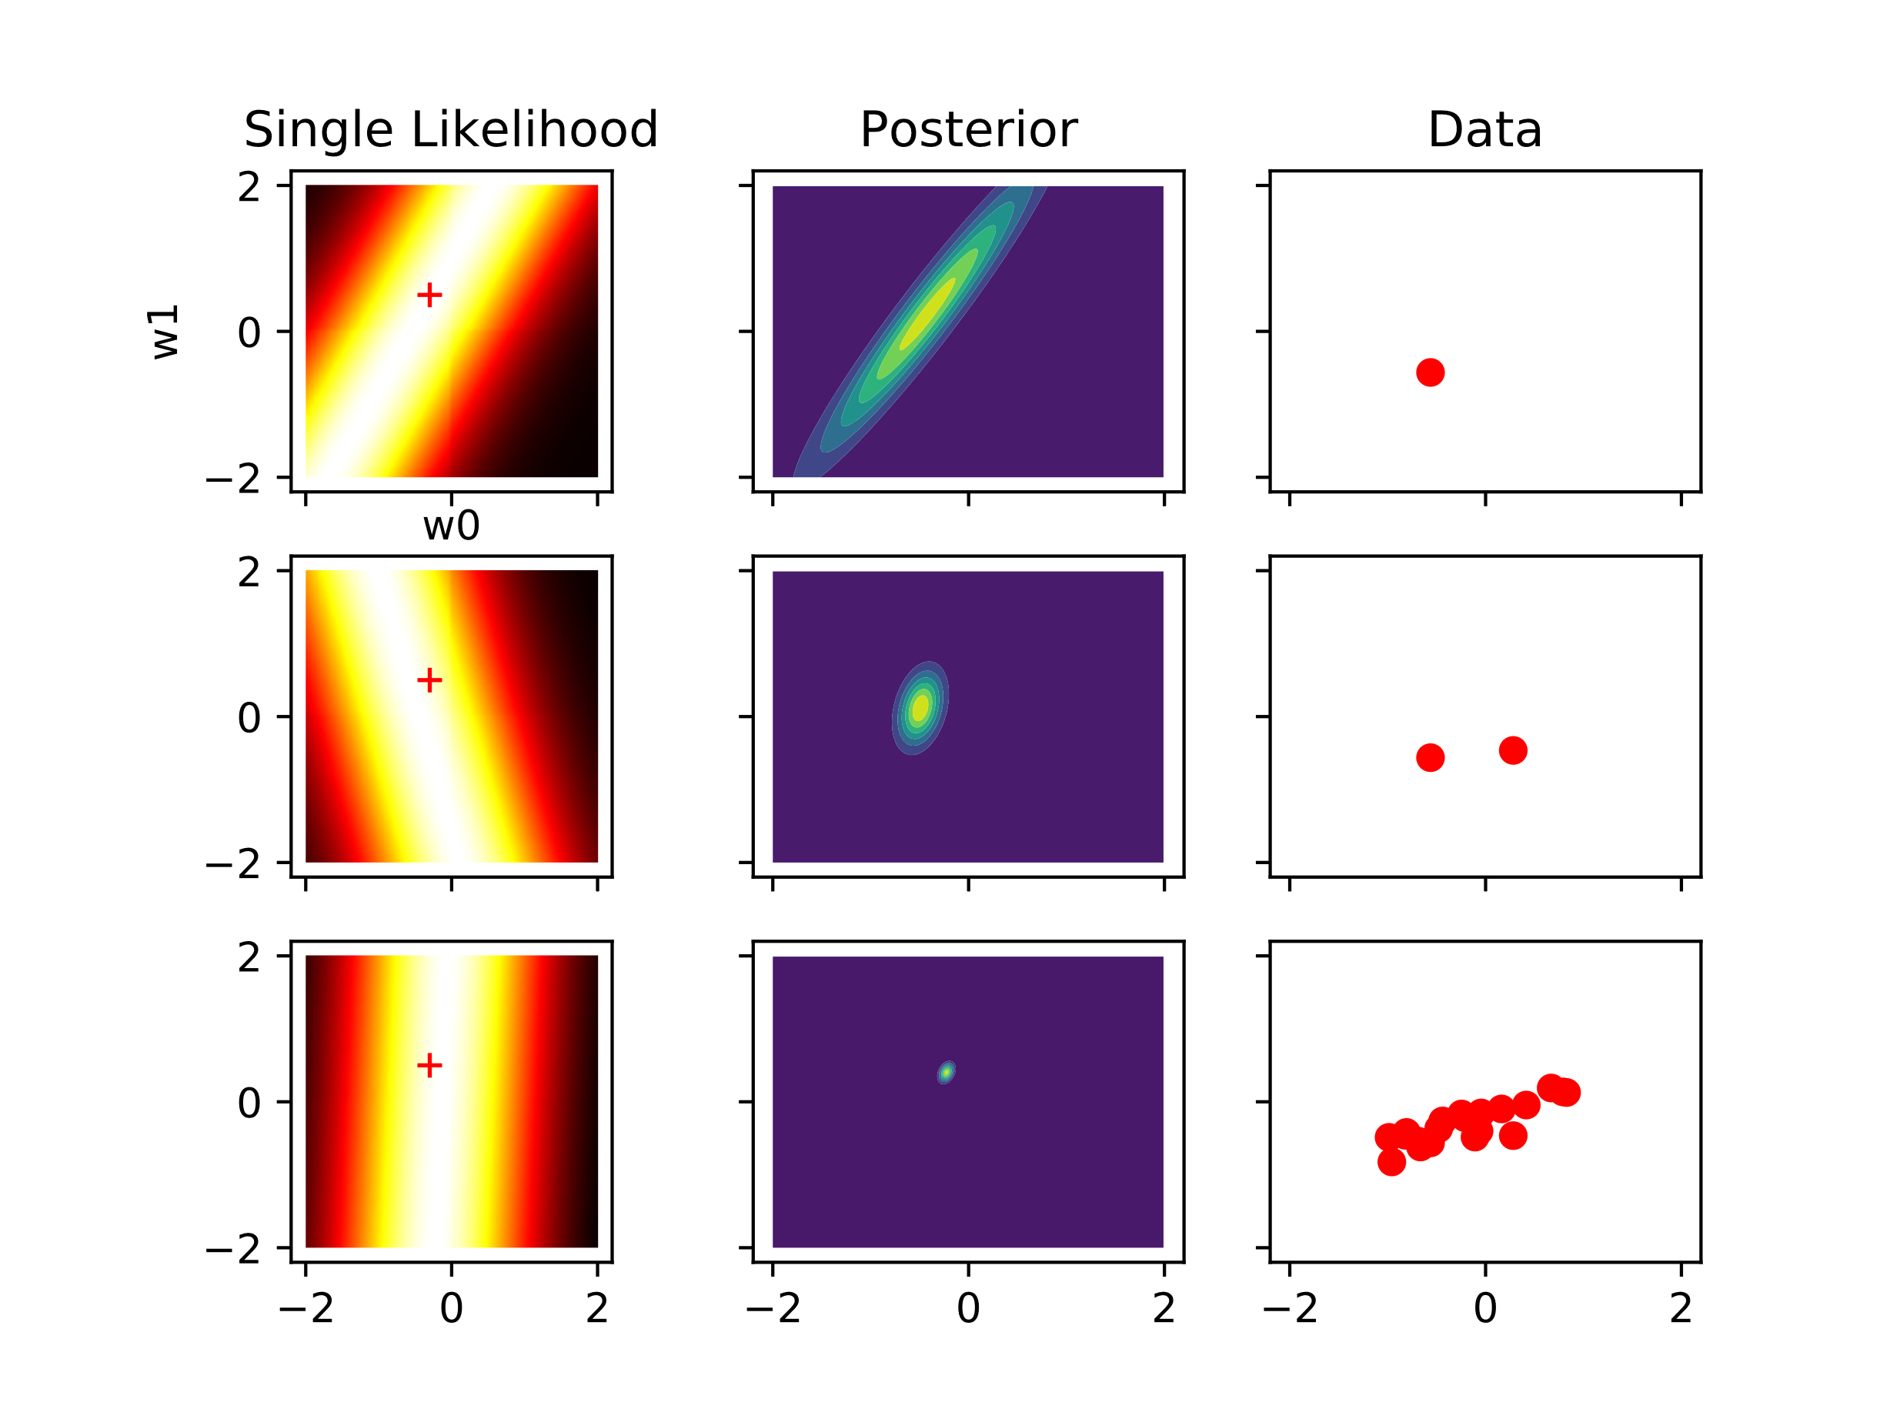
Figure 1 Replication of Bishop’s Figure 3.7 in Python. The Likelihood is of a single data point
  - 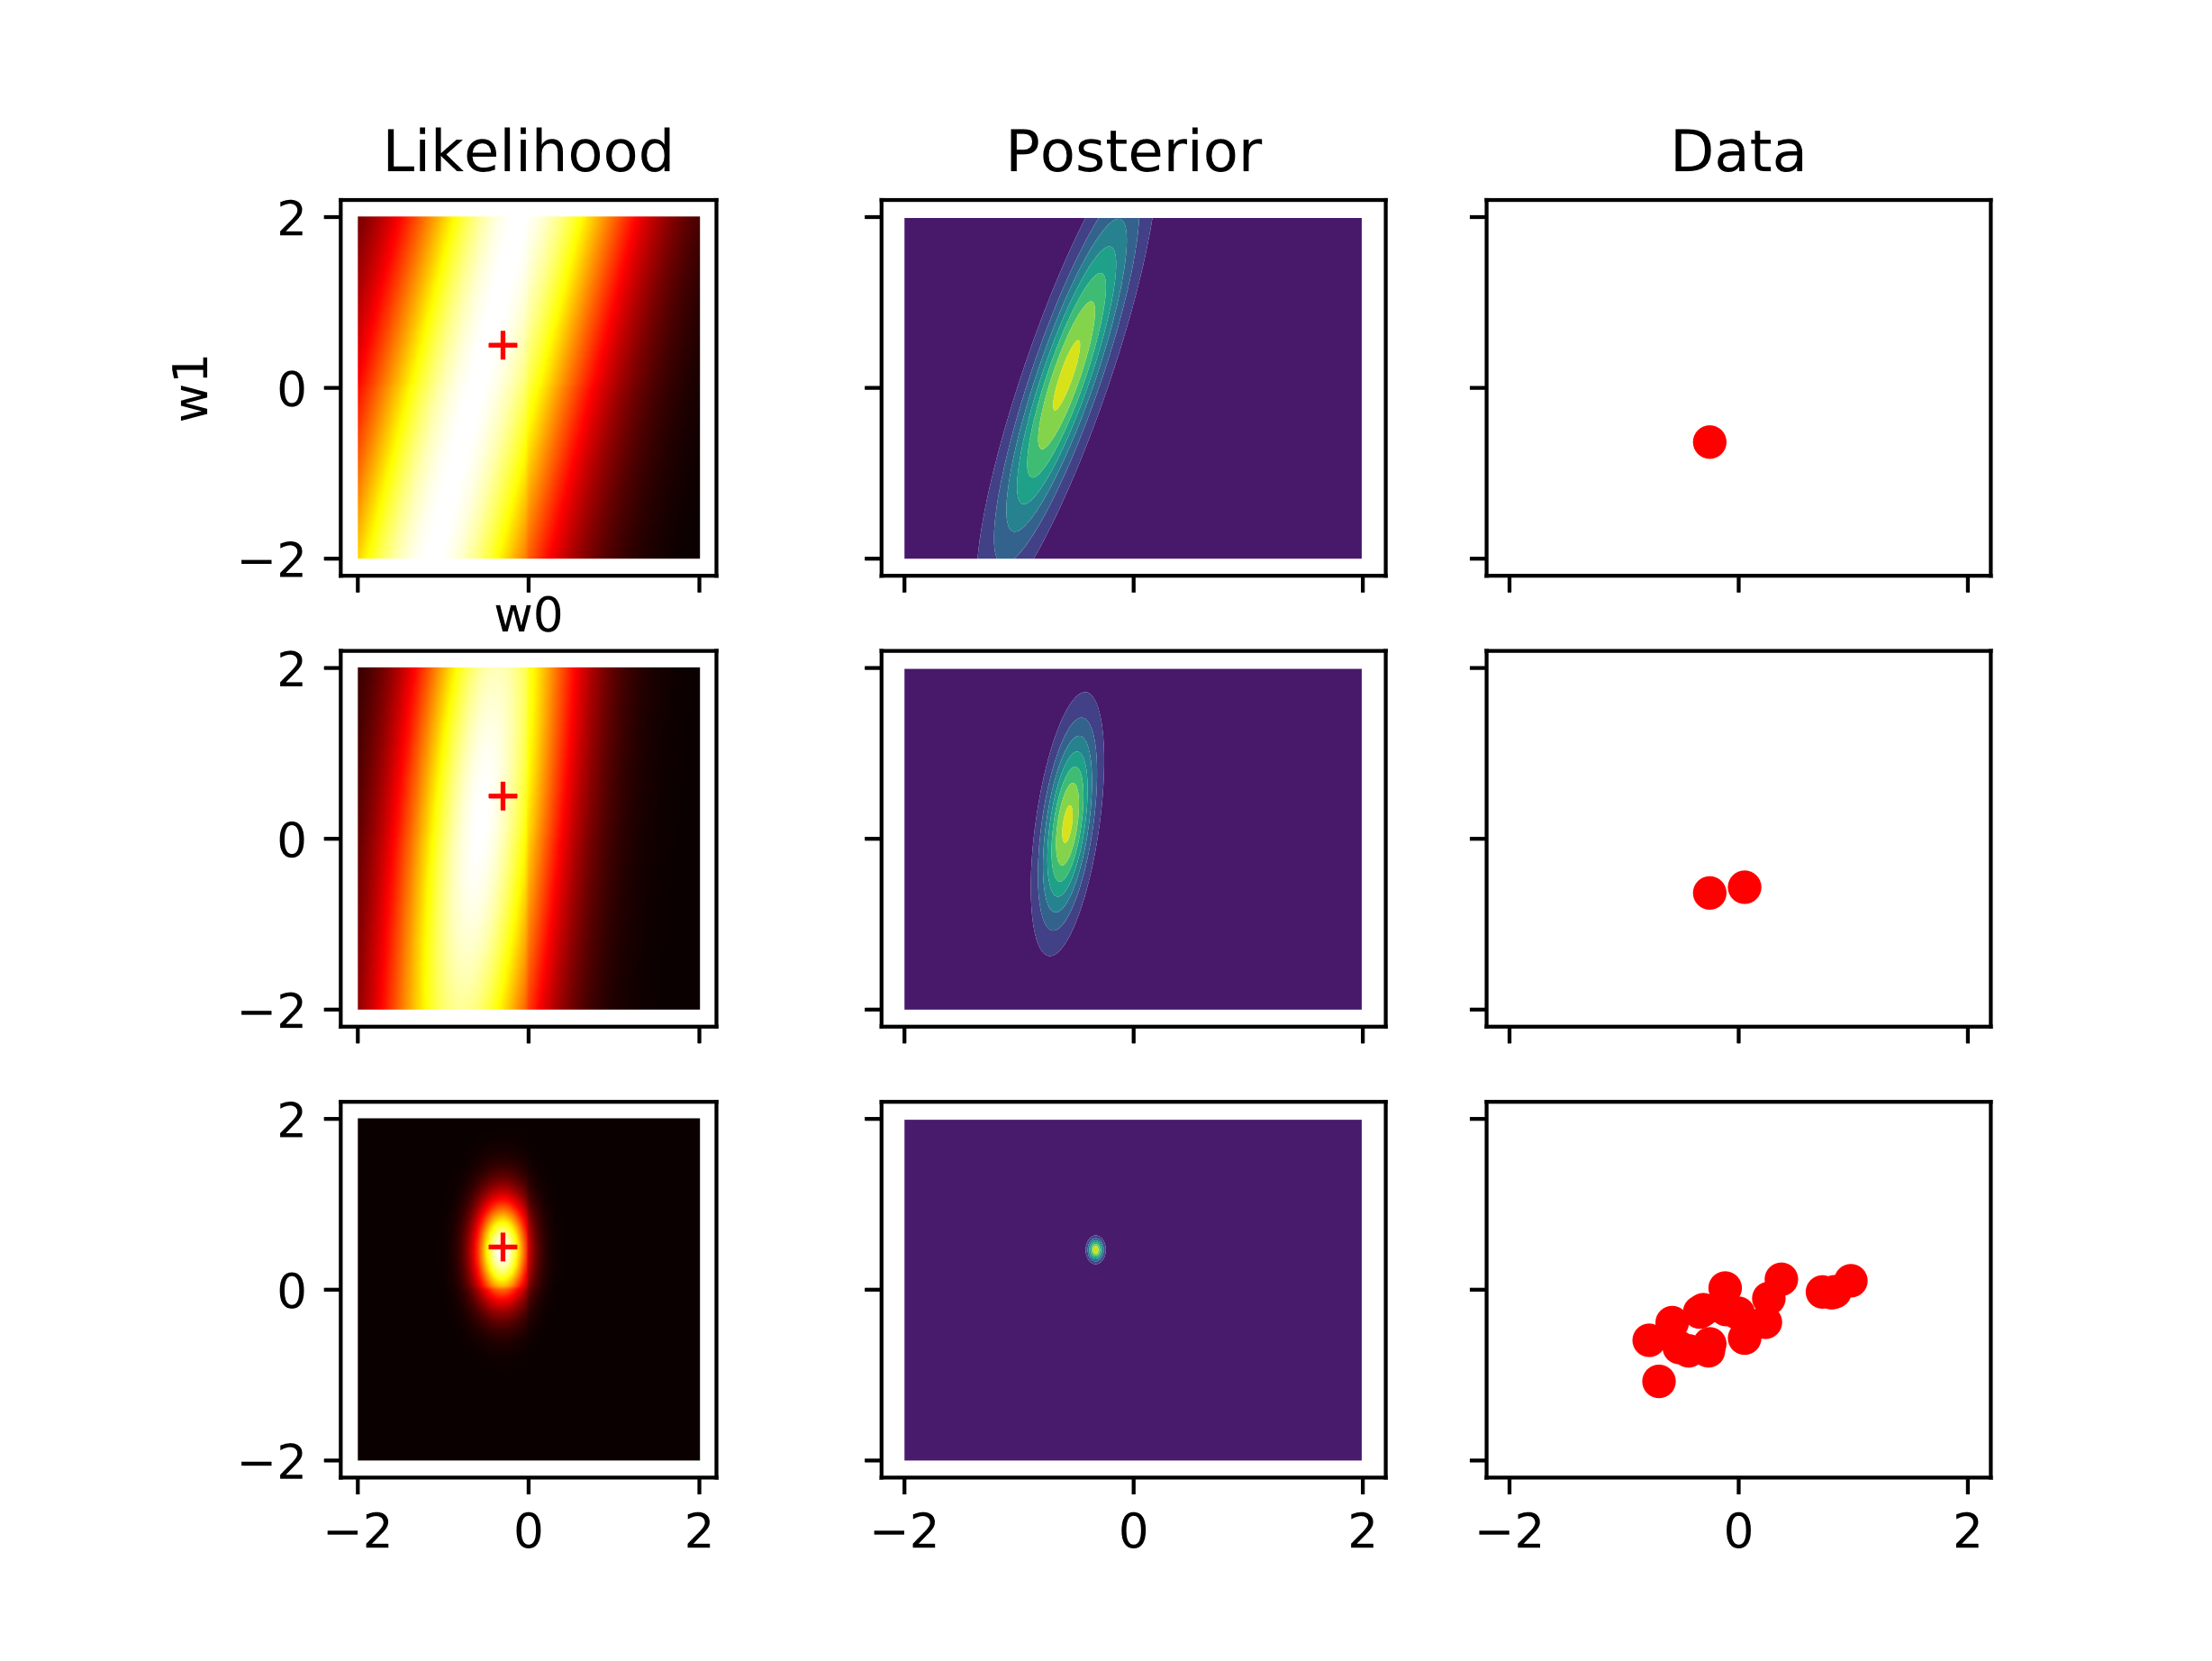
Figure 2 Replication of Bishop’s Figure 3.7 in Python this time with joint likelihood of the samples.

